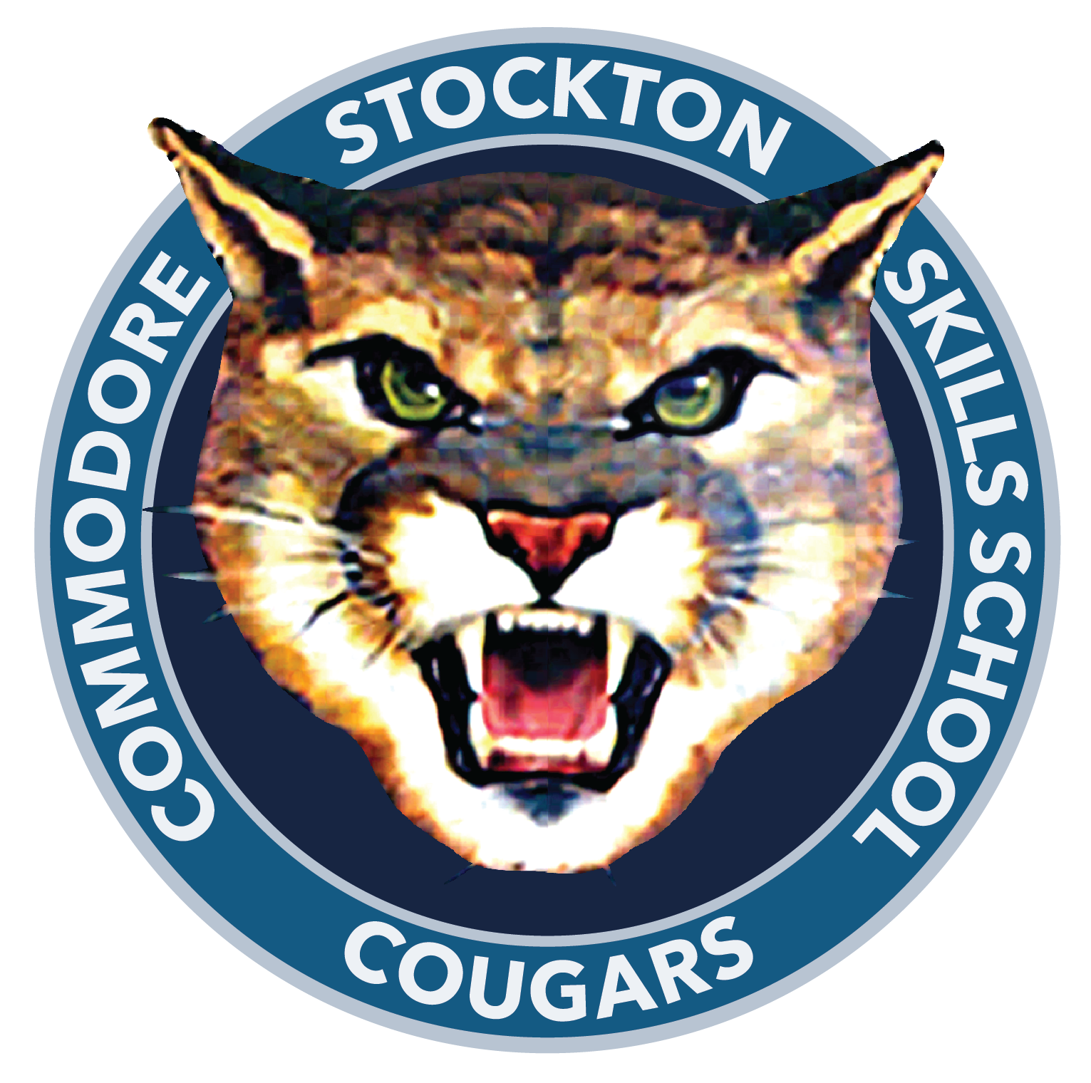

Commodore Stockton Skills School
2725 Michigan Avenue
Stockton, California • 95204
(209) 933-7170 • Fax (209) 466-3711
Clare Stubblefield, Principal
Ashlee Frades, Assistant Principal

Commodore Stockton Skills Student Dress Code Policy/Board Policy

Commodore Stockton Skills School believes that appropriate dress and grooming contribute to a productive learning environment. The school expects students to give the proper attention to personal cleanliness and wear clothes that are suitable for the school activities in which they participate. Students dress must promote a healthy, safe, wholesome environment and not cause a distraction that would interfere with the educational process.
The administration will make the final determination of whether a student’s dress and grooming meet district standards.
In accordance with California Administrative Code, title V, Section 302: “ Any person who comes to school without proper attention having been given to personal cleanliness or neatness of dress may be sent home to be properly prepared for school, or shall be required to prepare him/herself for the school room before entering.”

General Rules:
Clothing should meet the following requirements:
- Be properly fitted to the student, covering all undergarments.
- Cover the shoulders with a minimum of 4 fingers wide.
- Cover the student’s body from shoulder to mid-thigh.
- Allow for the full range of motion to participate in PE.
- Shoes must protect the toes, be secured with a back strap, and be appropriate for PE.
- Promote a positive, distraction free learning environment.

Head Coverings such as bandanas, beanies, earmuffs, baseball caps, etc. are not allowed unless worn for religious beliefs or spirit days.

Clothing that is Offensive or support illegal activity are not allowed. For Example:
- Clothing that advertise or has symbols that are known to be affiliated with illegal activities, including alcohol, tobacco, drugs, death and violence
- Garments displaying logos of racist groups or juvenile gangs, obscene language, vulgar gestures, racist, ethnic or sexual symbols or slurs or symbols of hate, prejudice, intolerance or discrimination or any clothing, jewelry, belts with the symbol of the Iron Cross
- Gang-related apparel which includes sports jerseys(except on “spirit” days)

Consequences vary depending on grade level but may include:
- Students may be required to change into loaned clothing items
- Parents may be called to bring a change of clothes
- Violation of the dress code may result in a discipline referral and confiscation of the item
- Subsequent infractions may result in a parent conference and be subject to progressive discipline

